***ARIGNAR ANNA GOVERNMENT ARTS COLLEGE***

**MUSIRI- 621 211**

**Affiliated to Bharathidasan University, Thiruchirapalli**

NAAN MUDHALVAN PROJECT

COURSE : DATA LITERACY WITH TABLEAU

PROJECT TITTLE: ANALYSING SPENDING BEHAVIOUR AND IDENTIFYING

OPPORTUNITIES FOR GROWTH

SUBMITTED BY

**TEAM NM ID: NM2023TMID25455**

TEAM LEADER:

S. ABINAYA (C91C3E92ACB0F5DA4E3472486A653742)

TEAM MEMBERS:

K. CHANDRAKUMAR (A779311D1C7C23FFA7624BDBA1615F011)

N. DHANALAKSHMI (52A79595C22FB8DA3504CA3C2EFCA73A)

**MENTOR SUPPORT: C.SIVAKUMAR**

INTRODUCTION:

# Wholesaling or distributing is the sale of goods or merchandise to retailer to industrial, commercial, institutional or other professional businessman to other wholesalers (wholesale businesses) and related subordinated services. In general, it is the sale of goods in bulk to anyone, either a person or an organization, other than the end consumer of that merchandise. Wholesaling is buying goods in bulk quantity, usually directly from the manufacturer or source, at a discounted rate. The retailer then sells the goods to the end consumer at a higher price making a profit.

# The consumption and production of marketed food are spatially separated. Production is primarily in rural areas while consumption is mainly in urban areas.

**Milestone 1: Define Problem / Problem Understanding**

**Activity 1: Specify the business problem**

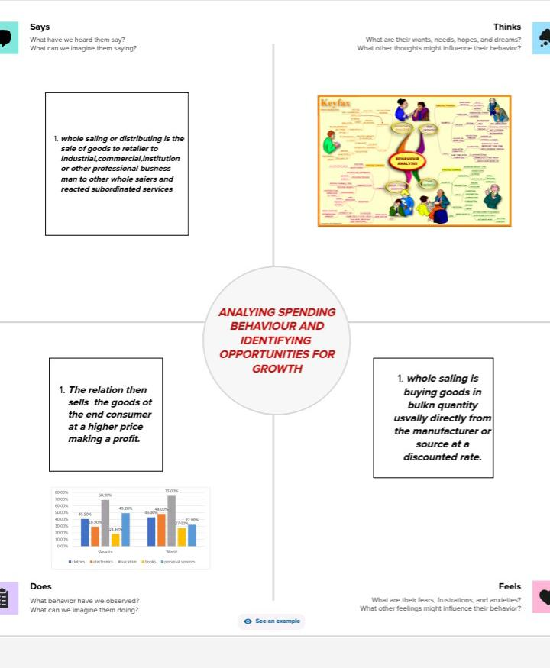

**Activity 2: Requirements**

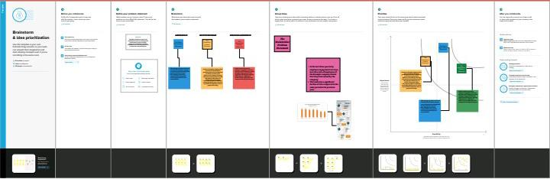

**Milestone 2: Data Collection & Extraction**

Data collection is the process of gathering and measuring information on variables of interest, in an established systematic fashion that enables one to answer stated research questions, test hypotheses, and evaluate outcomes and generate insights from the data.

**Activity 1: Collect the dataset**

<https://drive.google.com/file/d/16Lwm4oId6LUnFGXWflMMYm10zynmvuE0/view>

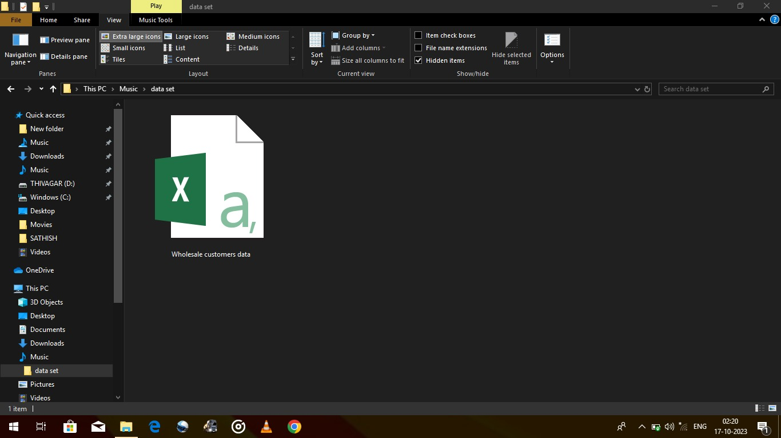

**Activity 2:Connecting Dataset to Tableau :**

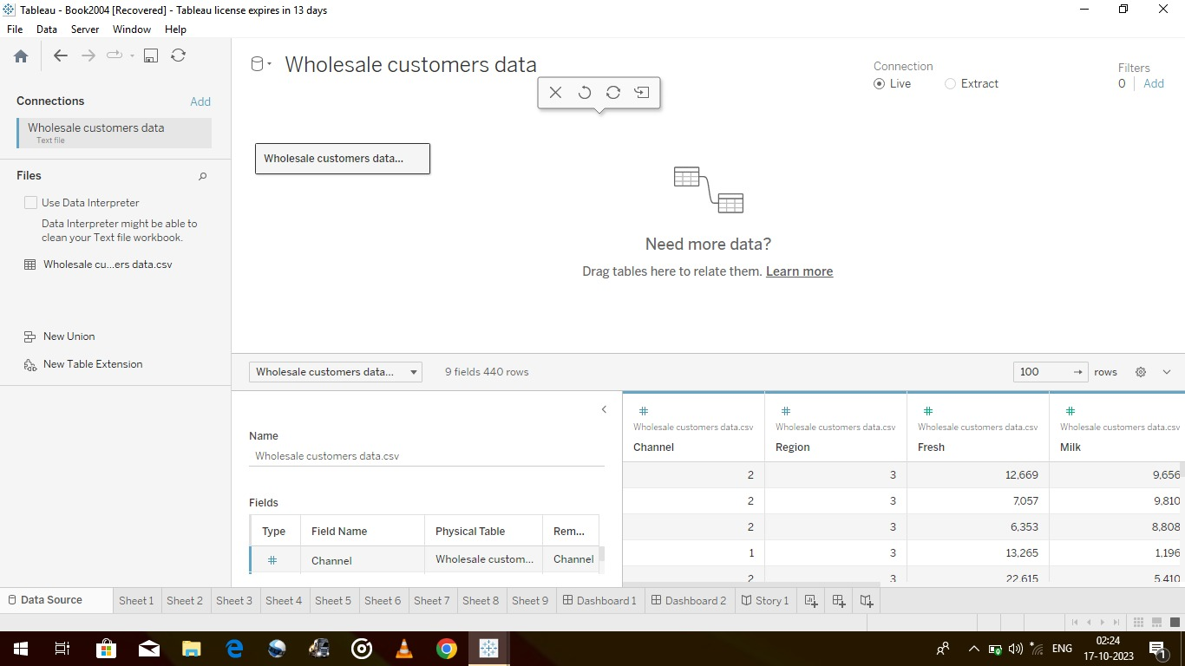

**Milestone 3: Data Preparation**

**Activity 1: Prepare the Data for Visualization**

Data modules are containers that describe data and rules for combining and shaping data to prepare it for analysis and visualization in Tableau. Data module sources. Data modules can be based on data servers, packages, uploaded files, data sets, and other data modules.

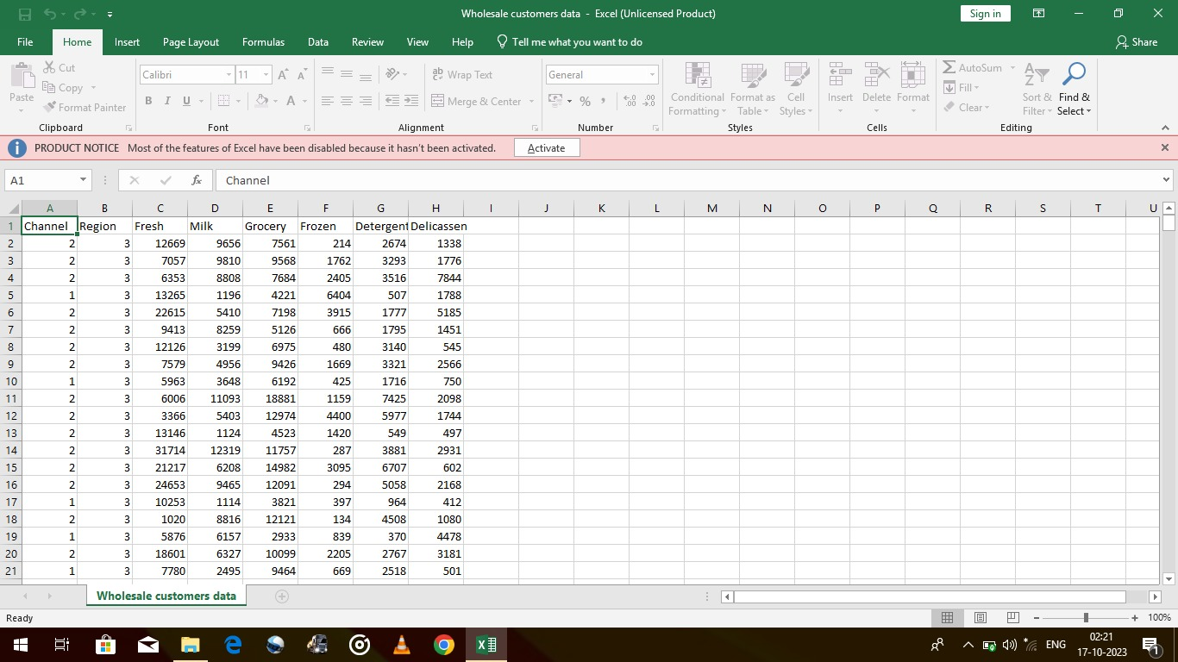**Milestone 4: Data Visualization :**

Data visualization is the process of creating graphical representations of data in order to help people understand and explore the information. The goal of data visualization is to make complex data sets more accessible, intuitive, and easier to interpret. By using visual elements such as charts, graphs, and maps, data visualizations can help people quickly identify patterns, trends, and outliers in the data.

**Activity 1: No of Unique Visualizations :**

The number of unique visualizations that can be created with a given dataset. Some common types of visualizations that can be used to analyze the performance and efficiency of a project include bar charts, line charts, heat maps, scatter plots, pie charts, Maps, etc. These visualizations can be used

to compare performance, track changes over time, and show distribution, and relationships between variables.

**Activity 1.1: KPI’s**

[**https://drive.google.com/file/d/1jbDOuCauhVNtI7BV0HSq1HU7FYGItWoM/view?usp=drive_link**](https://drive.google.com/file/d/1jbDOuCauhVNtI7BV0HSq1HU7FYGItWoM/view?usp=drive_link)

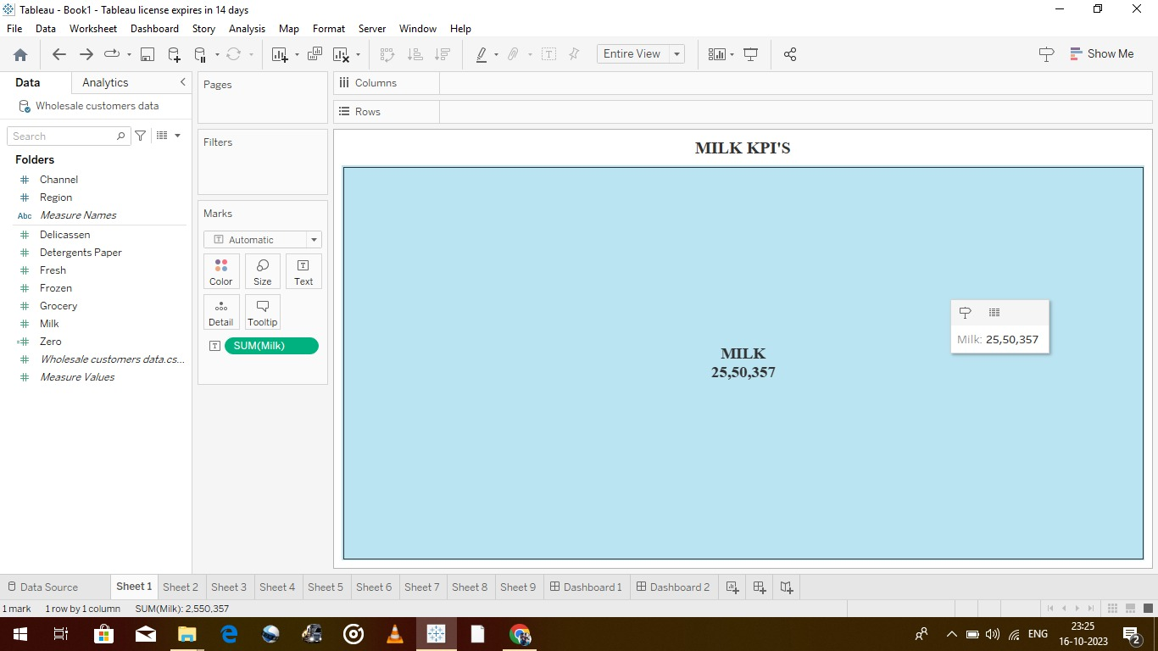

GROCERY

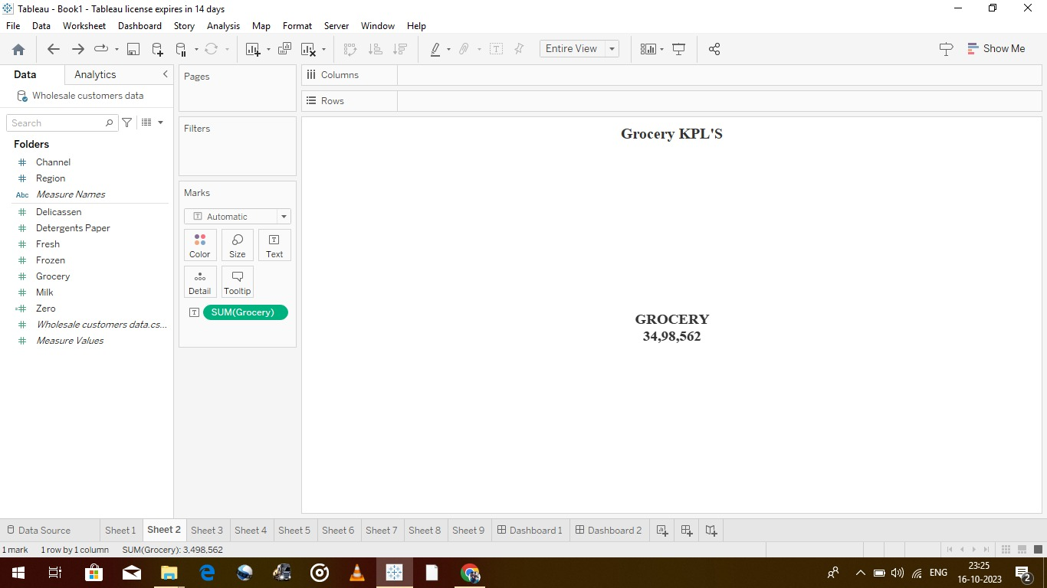

FRESH

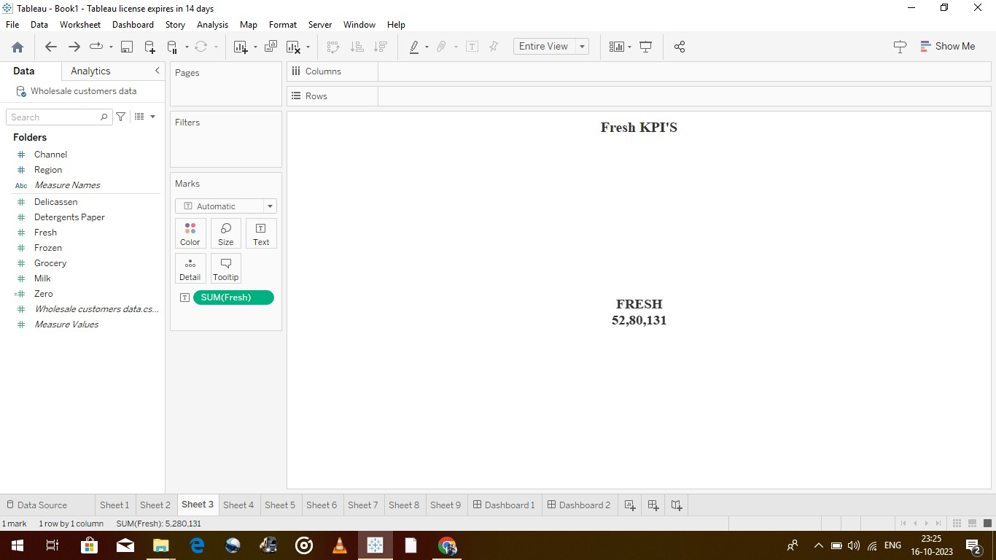

**Activity 1.2: Region Wise Detergent paper and grocery :**



[**https://drive.google.com/file/d/1b1dhVmo8ONLiQdWQ8_zH9OVBqW1xTwfW/view?usp=drive_link**](https://drive.google.com/file/d/1b1dhVmo8ONLiQdWQ8_zH9OVBqW1xTwfW/view?usp=drive_link)

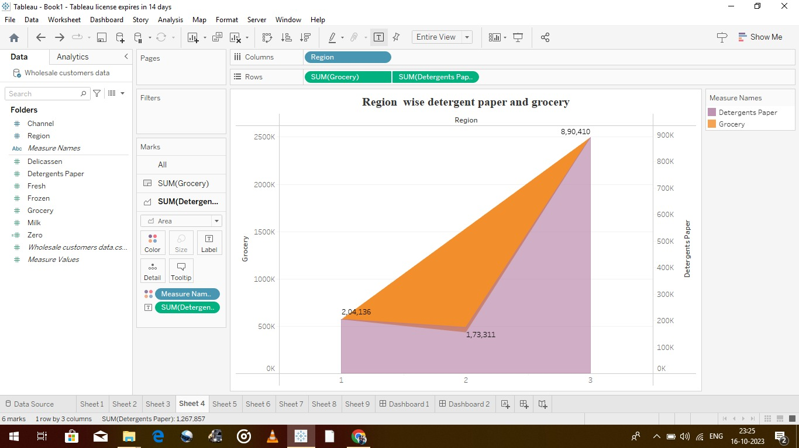

**Activity 1.3: Region wise Milk :**

[**https://drive.google.com/file/d/160HV-kdO8GelUM3yk8UvxnNZEHwAkg6F/view?usp=drive_link**](https://drive.google.com/file/d/160HV-kdO8GelUM3yk8UvxnNZEHwAkg6F/view?usp=drive_link)

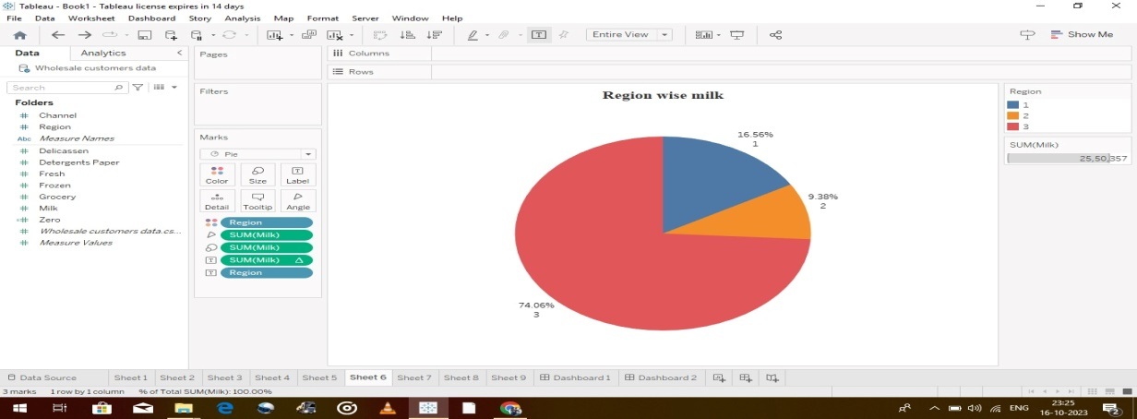

**Activity 1.4: Channel wise frozen and Delicatessen :**

[**https://drive.google.com/file/d/1oyVuE7LogghwNI8qMUs4QpIB0539AxMR/view?usp=drive_link**](https://drive.google.com/file/d/1oyVuE7LogghwNI8qMUs4QpIB0539AxMR/view?usp=drive_link)

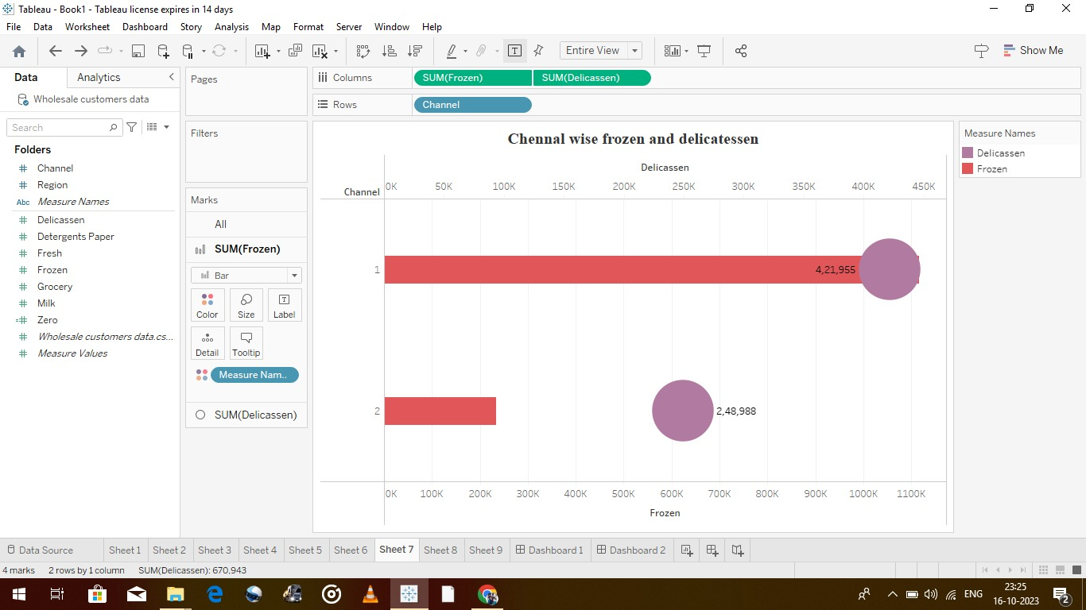

**Activity 1.5: Region wise Delicatessen and Detergent paper :<https://drive.google.com/file/d/17RWqG5p5l3Y_CoccYdY8A3RABn3DhXX8/view?usp=drive_link>**

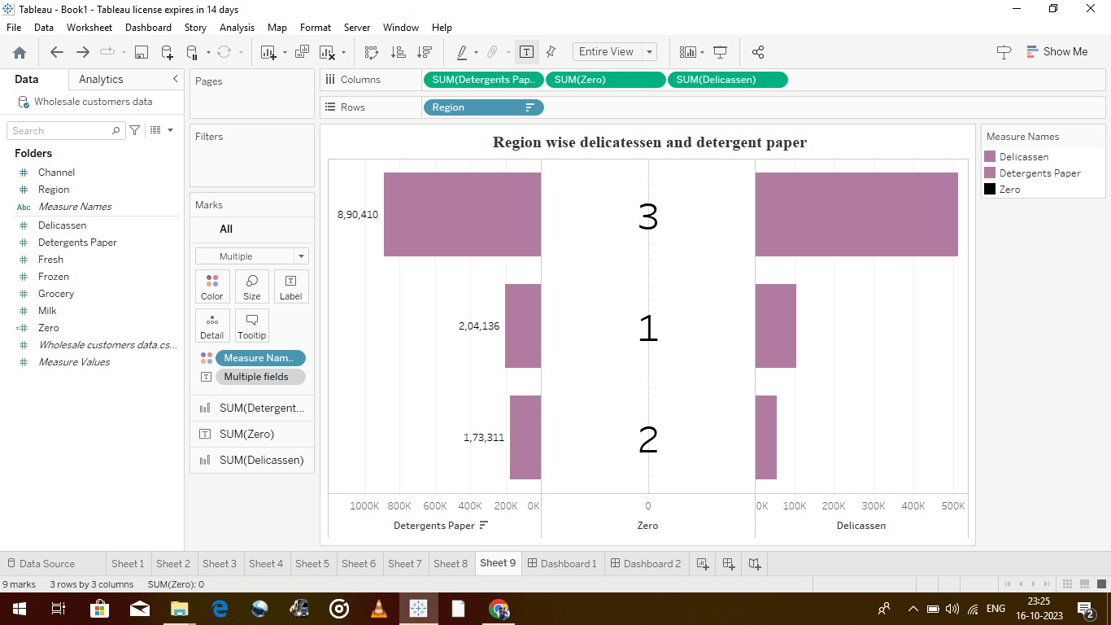

**Activity 1.6: Channel wise grocery and Detergent paper :**

[**https://drive.google.com/file/d/1VTQfetbncufnVML6qaGEd-BSr2IY1EG8/view?usp=drive_link**](https://drive.google.com/file/d/1VTQfetbncufnVML6qaGEd-BSr2IY1EG8/view?usp=drive_link)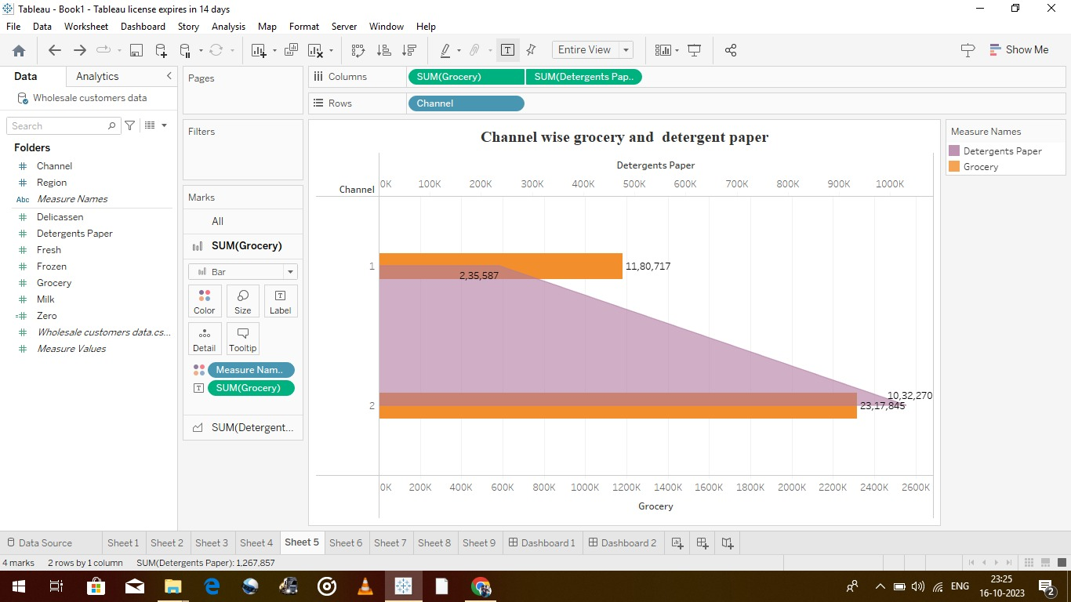

**Activity 1.7: Region Wise Delicatessen :**

[**https://drive.google.com/file/d/1OpednCASc6fwcEpDqEcxMUpR3VuXT5zg/view?usp=drive_link**](https://drive.google.com/file/d/1OpednCASc6fwcEpDqEcxMUpR3VuXT5zg/view?usp=drive_link)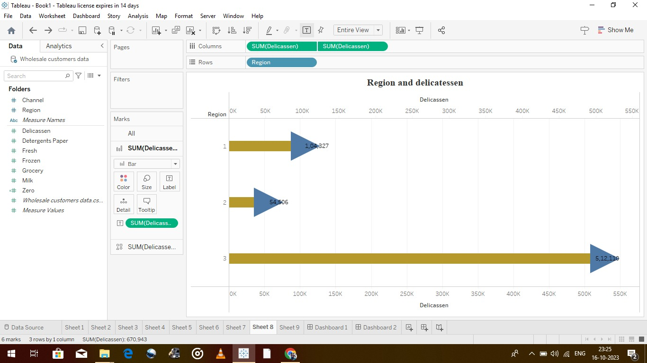

**Milestone 5: Dashboard :**

A dashboard is a graphical user interface (GUI) that displays information and data in an organized, easy-to-read format. Dashboards are often used to provide real-time monitoring and analysis of data, and are typically designed for a specific purpose or use case. Dashboards can be used in a variety of settings, such as business, finance, manufacturing, healthcare, and many other industries. They can be used to track key performance indicators (KPIs), monitor performance metrics, and display data in the form of charts, graphs, and tables.

**Activity :1- Responsive and Design of Dashboard :**

Once you have created views on different sheets in Tableau, you can pull them into a dashboard.

**Dashboard 1 :**

<https://public.tableau.com/app/profile/chandrakumar.k7278/viz/Book2004_16975258515050/Dashboard1?publish=yes>

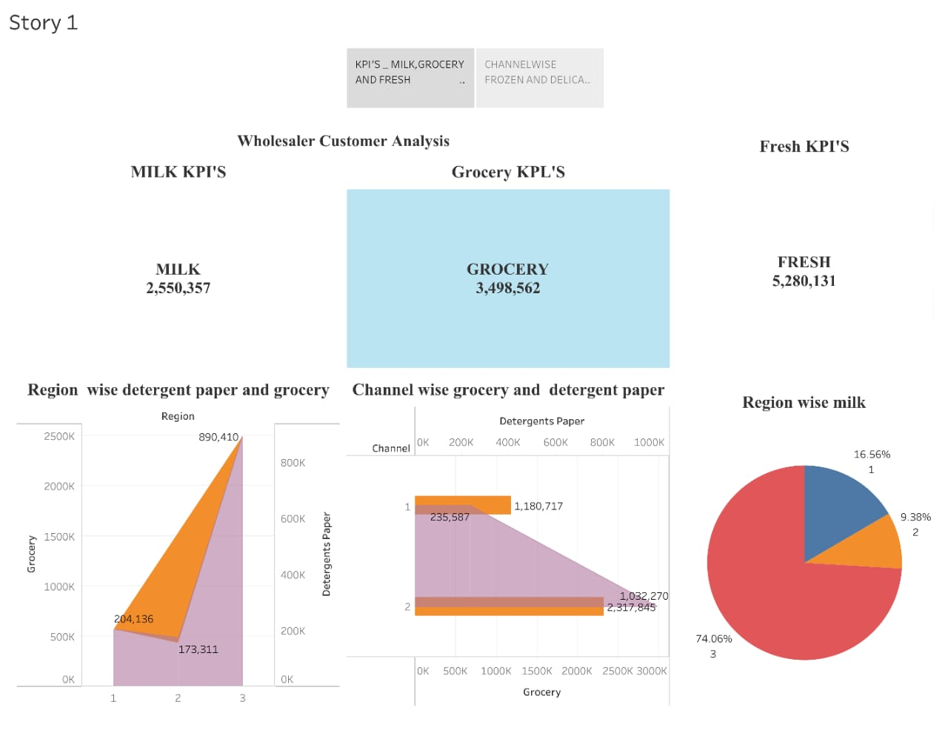

**Dashboard 2 :**

<https://public.tableau.com/app/profile/chandrakumar.k7278/viz/Book2004_16975258515050/Dashboard2?publish=yes>

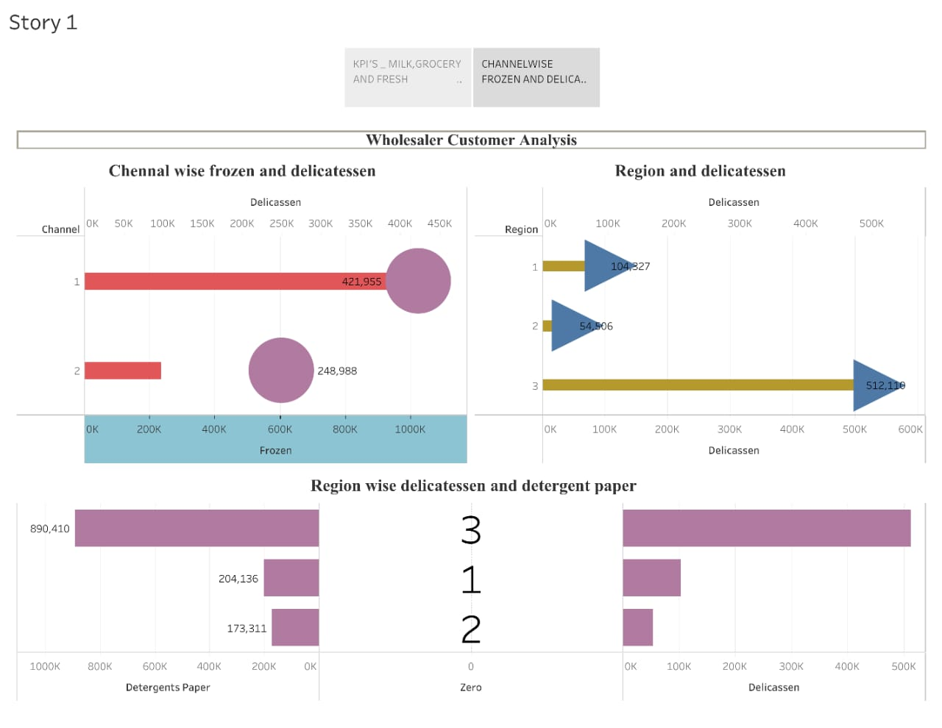

**Milestone 6: Story :**

A data story is a way of presenting data and analysis in a narrative format, with the goal of making the information more engaging and easier to understand. A data story typically includes a clear introduction that sets the stage and explains the context for the data, a body that presents the data and analysis in a logical and systematic way, and a conclusion that summarizes the key findings and highlights their implications. Data stories can be told using a variety of mediums, such as reports, presentations, interactive visualizations, and videos

**Story link :**

<https://public.tableau.com/app/profile/chandrakumar.k7278/viz/Book2004_16975258515050/Story1?publish=yes>





**Milestone 7: Performance Testing :**

**Activity 1: Amount of Data Rendered to Tableau**

1. The amount of data that is rendered to a Tableau depends on the size of the dataset

**Activity 2: No of Calculation Fields :**

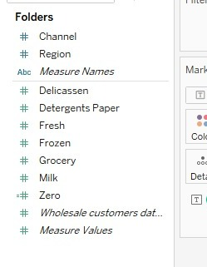

**Activity 4: No of Visualizations/ Graphs**

1. KPI
2. Region Wise Detergent paper and grocery
3. Region wise Milk
4. Channel wise frozen and Delicassen
5. Region wise Delicassen and Detergent paper

6. Channel wise grocery and Detergent paper

7. Region Wise Delicassen

**Milestone 8: Publishing**

Publishing helps us to track and monitor key performance metrics, to communicate results and progress. help a publisher stay informed, make better decisions, and communicate their performance to others.

**Dashboard 1 :**

<https://public.tableau.com/app/profile/chandrakumar.k7278/viz/Book2004_16975258515050/Dashboard1?publish=yes>

**Dashboard 2 :**

<https://public.tableau.com/app/profile/chandrakumar.k7278/viz/Book2004_16975258515050/Dashboard2?publish=yes>

**Story link :**

<https://public.tableau.com/app/profile/chandrakumar.k7278/viz/Book2004_16975258515050/Story1?publish=yes>

**Reference Video :**

**Conclusion :**

* **Understanding your existing customers**
* Why do customers choose your product over competitors? What do they value? Is it service, product quality or the prestige associated with consuming your product/service? Who influences their buying decision? What magazines do they read? What websites do they visit? What do they enjoy doing?
* To make your market research analysis to the next level and drive your business forward, request a demo from Aim Technologies. Our cutting-edge solution and expertise in market research and provide you with actionable insights that will propel your business to new height. Don’t miss out on the opportunity to make data driven decision and stay ahead of the competition.

***THANIKING NAAN MUTHALVAN &***

***GOVERNMENT OF TAMILNADU***